

**Skill Scope**

**Abstract:**

In an increasingly competitive job market, personalized career guidance and skill development are essential for job seekers to maximize their employment opportunities. This project presents a comprehensive web-based platform designed to guide users toward achieving their career goals in technology-driven fields such as Web Development, Data Science, Machine Learning, and Artificial Intelligence. By integrating a user-centered approach with advanced algorithms, the platform provides a structured, personalized journey from skill assessment to job recommendation.

The system begins by gathering user data through a survey to understand each user's background, education, and career interests. Based on this data, the platform suggests relevant fields, and users can select a specific area of interest. The platform then allows users to choose their preferred technology stack (e.g., React, Angular, Node.js), offering insights into the job market by displaying available job opportunities across different experience levels—intern, entry, mid, and experienced.

To ensure users are equipped with the necessary skills, the platform provides a skills combination recommendation tailored to each chosen stack. Users can test their proficiency, and based on the results, receive a customized learning path that highlights essential resources for improving their expertise. Following this skill enhancement process, the platform recommends jobs suited to the user’s skillset, along with specific insights into how to tailor their CV to meet industry standards and maximize their employability.

This project aims to bridge the gap between education and employment by offering a data-driven, personalized roadmap for career growth. It empowers users to make informed decisions about skill development, enhances their job application materials, and ultimately increases their chances of securing desirable roles in the tech industry.

**Workflow:** 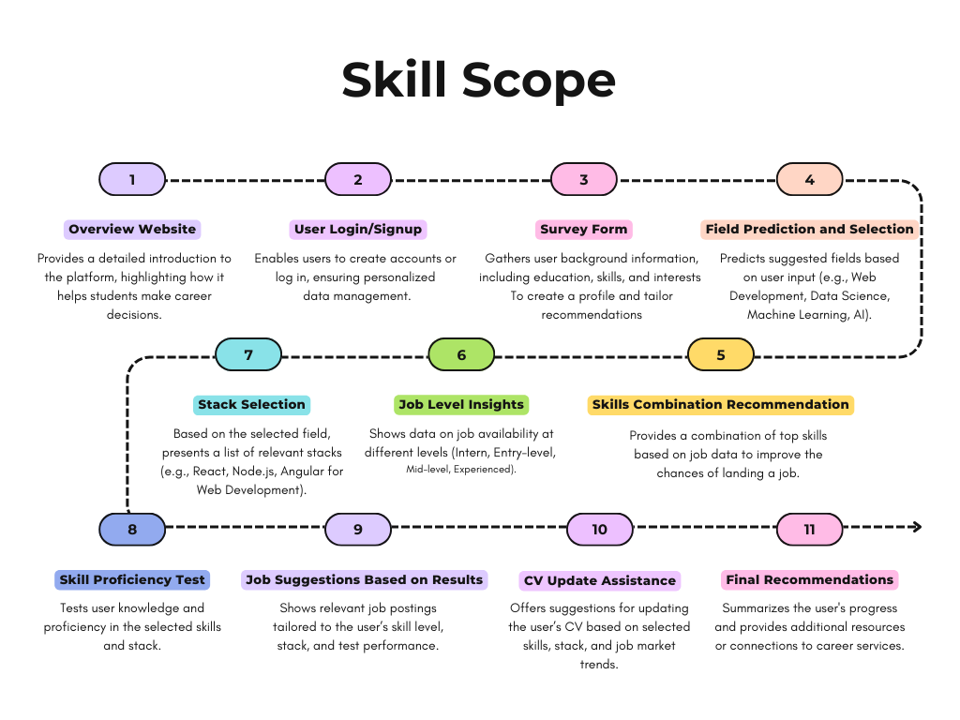

**Supervisors & Group Members:**

| **S. No:** | **Name** | **Designation** |
| --- | --- | --- |
| 1. | Miss Tehniyat Mirza | Supervisor |
| 2. | Miss Sumeera Hashmi | Co-Supervisor |
| 3. | Ali Salman | Team Lead |
| 4. | Hasnain Hafeez | Member 2 |
| 5. | Syed Rizwan Hussain | Member 3 |
| 6. | Hassan Ali Zain | Member 4 |